ECE593 Introduction to Machine Learning Homework 2
S, G, and Version Space
Bo Lin
Write a MATLAB program that finds S and G from a given training set and plots them on the graph as shown in the example below.
Also generate any other hypothesis for the version space and also plot it on the data.
Run your code for a different number of data points (for example, N=50,100,250,500) and discuss how the number of data points impacts S and G in terms of empirical error and generalization capability. Support you discussion with quantifiable metrics from the experiments.

I. Finding the most specific hypothesis “S”
The most specific hypotheses cover the observed positive training points, and as little of the remaining feature space as possible. Once get the “S”, if reduce any further from any direction of the rectangle, it will exclude a positive training data point. For this feature, an algorithm is developed to find the four axis boundaries for the rectangle. It is defined just by the positive data points already observed.
First, set Xa and Ya as maximum 5, Xb and Yb as minimum 0. In each iteration, the Xa and Ya will be compared with the inside data point position value and update with the smaller value, in contract, Xb and Yb will update with the bigger value. The data with “s” is shown in Fig.1 with training size 50.
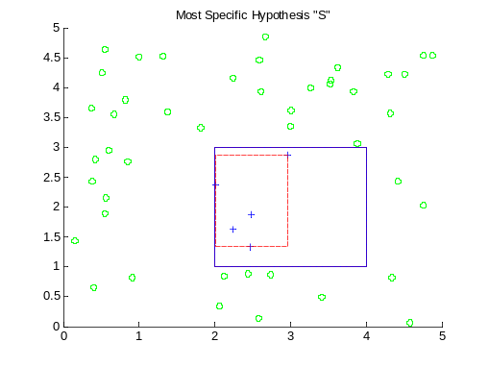
Figure 1 Most Specific Hypothesis “S” with training size 50

II. Finding the most general hypothesis “G”
The most general hypotheses cover the observed positive training points, but also cover as much of the remaining feature space without including any negative training examples. These, if enlarged any further, include a negative training point. It is defined just by the negative data points already observed.
While developing the algorithm, I did it in two ways. First, find the largest range for X axis and then for Y axis; Secondly, find the largest range for Y axis first and then X axis. These two methods use very similar codes but the result could be different. During training each data point, the data points that outside class C are used for updating axis value. The initial Xa and Ya are set to 0, Xb and Yb are set to 5. For each outside point the Xa and Ya are updated to the larger one, the Xb and Yb are updated to the smaller one. The training result of “G” is shown in Fig.2 and Fig.3. The training set is the same as in Section I. The yellow space is the version space between G and S.
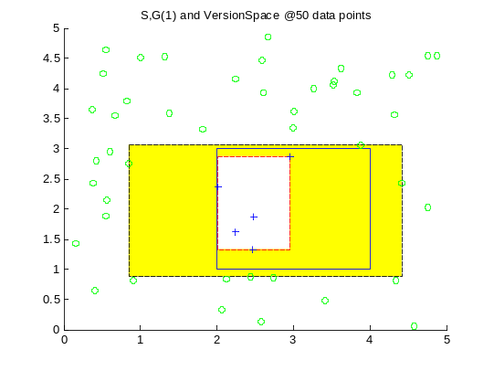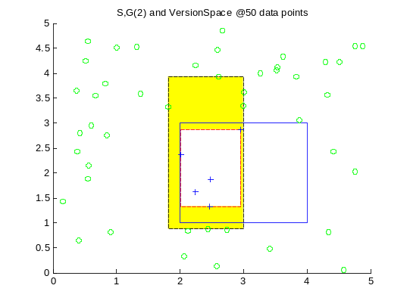
Figure 2 G1 with S Figure 3 G(2) with S

III. Empirical Error & Generalization Capability
After getting the S and G, a set of random data points are used to test the empirical error of the hypothesis class. For both class S and class G, a validation data set sizing from 50 to 250 is tested. For counting the empirical error, using 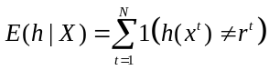 , the result is shown in Fig.4. The empirical error result is shown in Table 1.
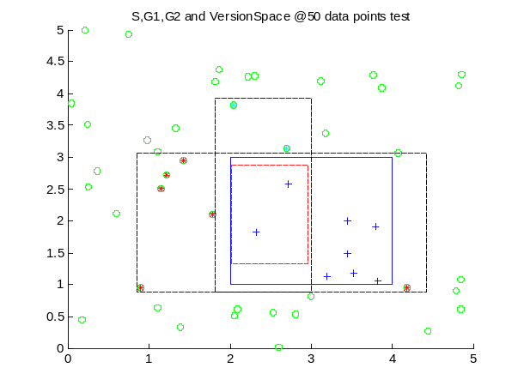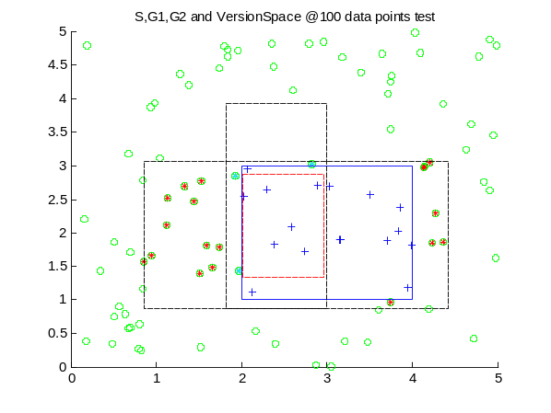
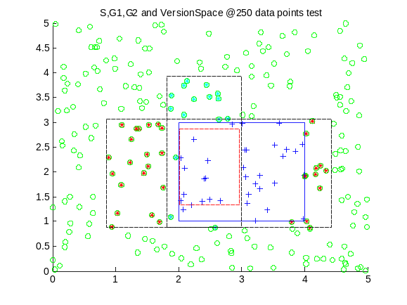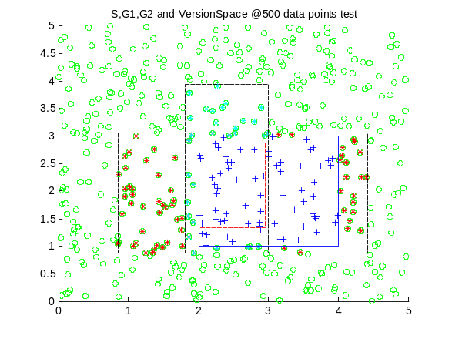
Figure 4 Empirical Error testing
Table 1 Validation dataset size effect on Empirical Error
Data Size  Class | 50 | 100 | 250 | 500
Class S | 6  12% | 11  11% | 21  8.4% | 42  8.4%
Class G1 | 6  12% | 21  21% | 35  14% | 79  15.8%
Class G2 | 2  4% | 3  3% | 15  6% | 30  6%
In Table 1, we can see that the empirical error has a direct proportion with the validation data size. The more data for validation, the more empirical error will be, however as long as the training period is done, the ratio of empirical error will remain almost the same as increasing or decreasing validation dataset size.
The generalization capability is the performance for unseen data of hypothesis class. It should be judged by the performance of minimizing the training error and whether it will have over fitting phenomena.
For training error, Fig. 5 shows training S and G using different training size [100, 250, 500, 10000] besides 50 and validation size is fixed at 100. As the training size increases, version space decreases, the probability that G1 equal to G2 increases. In addition, the training error decreases.
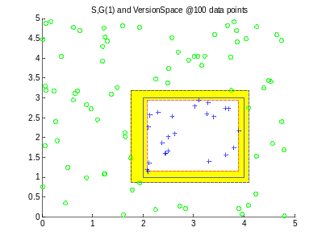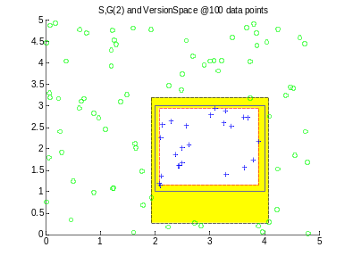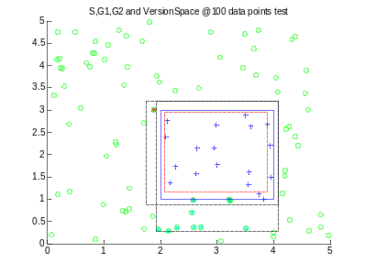
Figure 5(a) s=3 E(G1)=4,E(G2)=10 @100
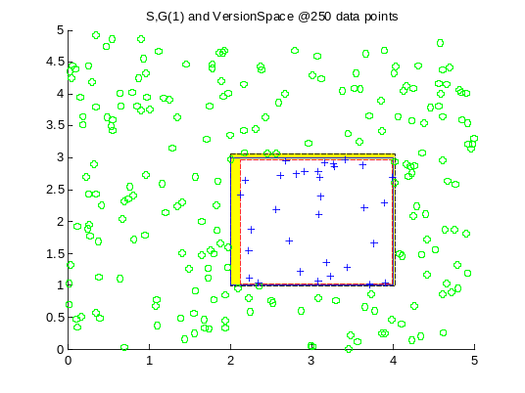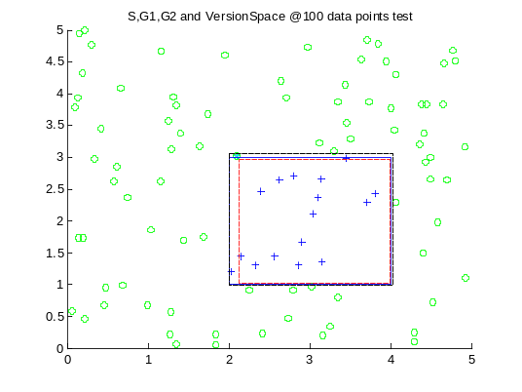
Figure 5(b) S=2 E(G)=1 @250
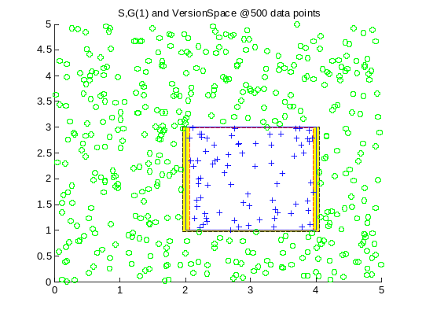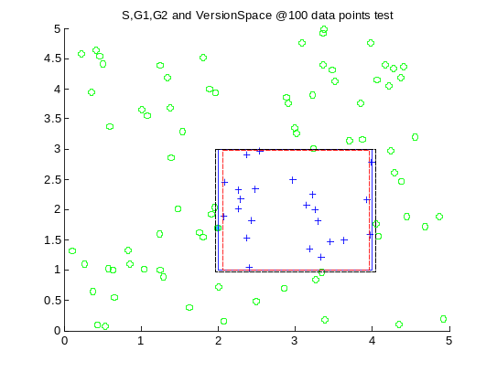
Figure 5(c) S=2 E(G)=1 @500
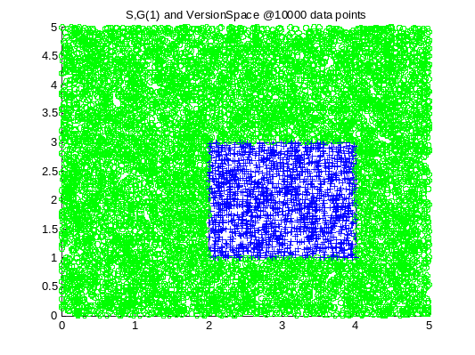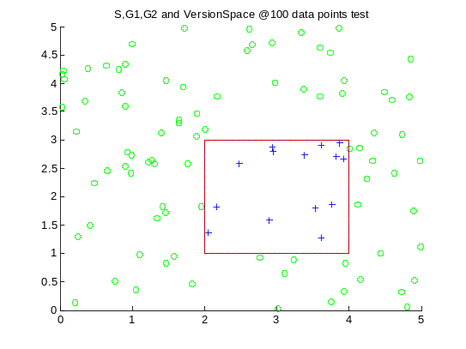
Figure 5(d) S=0 E(G)=0 @ 10000
Table 2 Training dataset Size affect Empirical Error
Data Size  Class | 100 | 250 | 500 | 1000
Class S | 3  3% | 2  0.8% | 2  0.4% | 0
Class G1 | 4  4% | 1  0.4% | 1  0.2% | 0
Class G2 | 10  10% | 1  0.4% | 1  0.2% | 0

For a fixed validation dataset size, the larger the training set size, the lower empirical error rate will be. That shows for a fixed size of total points, the more percentage of data used for training, the less error will there be.

